# **For Apache Pyspark Documentation, please follow following links:**

<https://spark.apache.org/docs/latest/api/python/index.html>

# **Apache Spark Ecosystem**

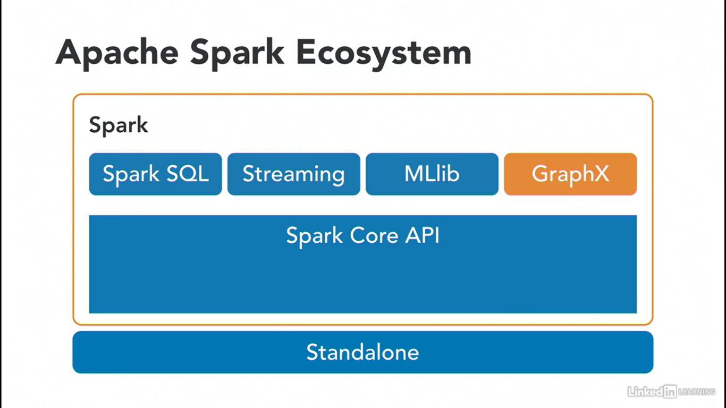

## **Spark Core API Components:**

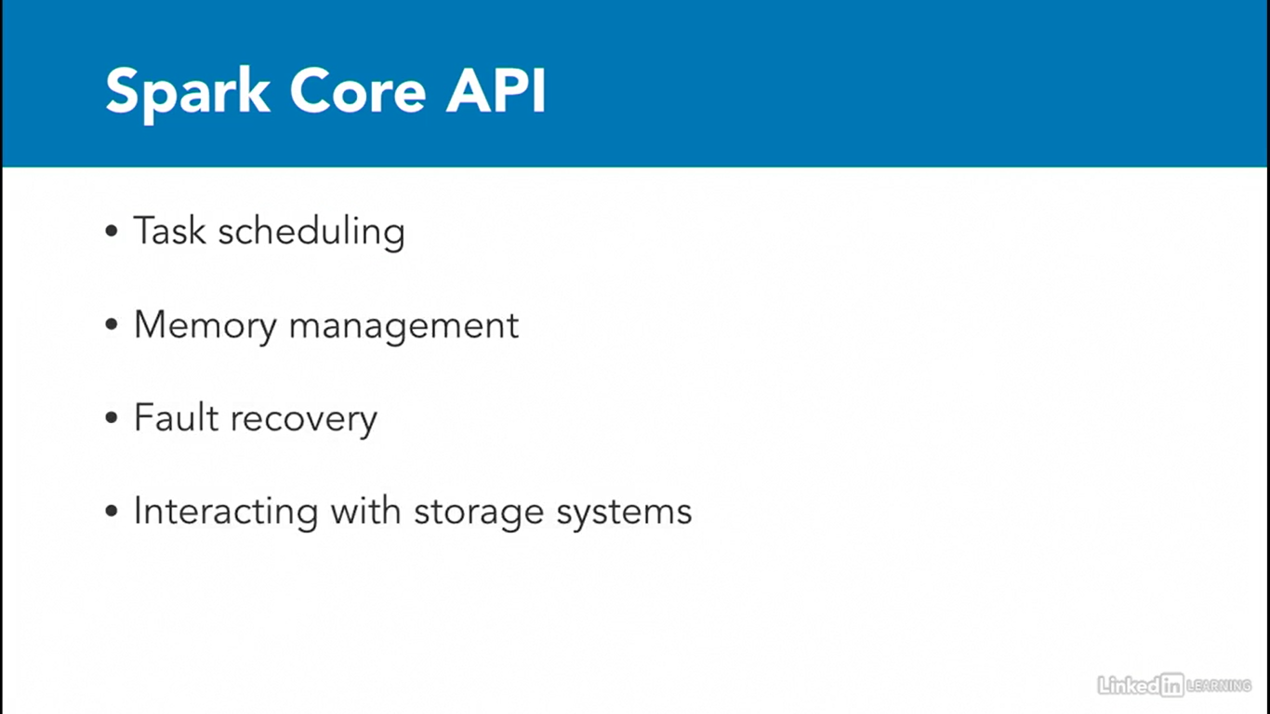

## **Spark SQL and Dataframes:**

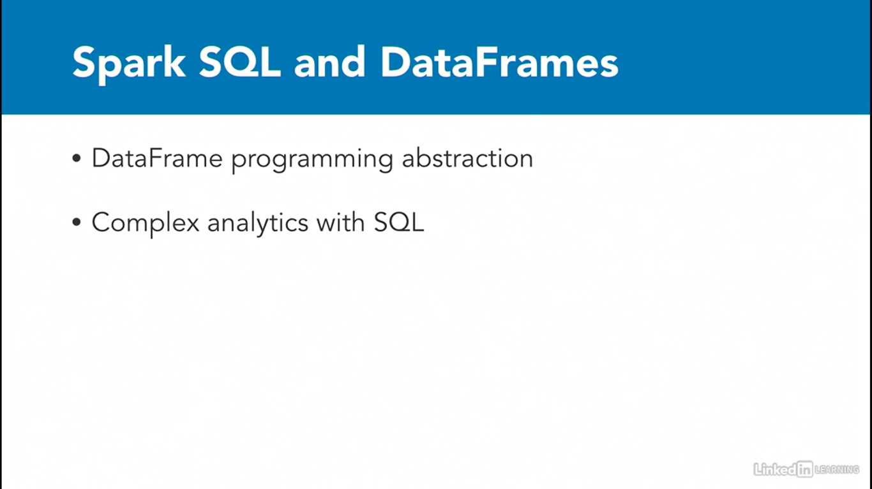

## **Spark Streaming:**

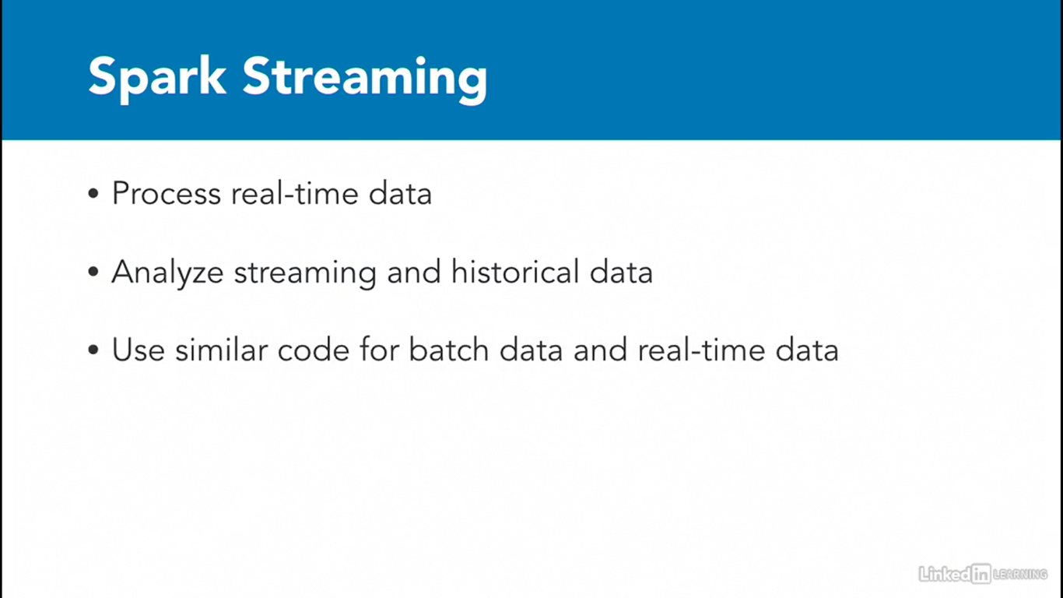

## **MLlib:**

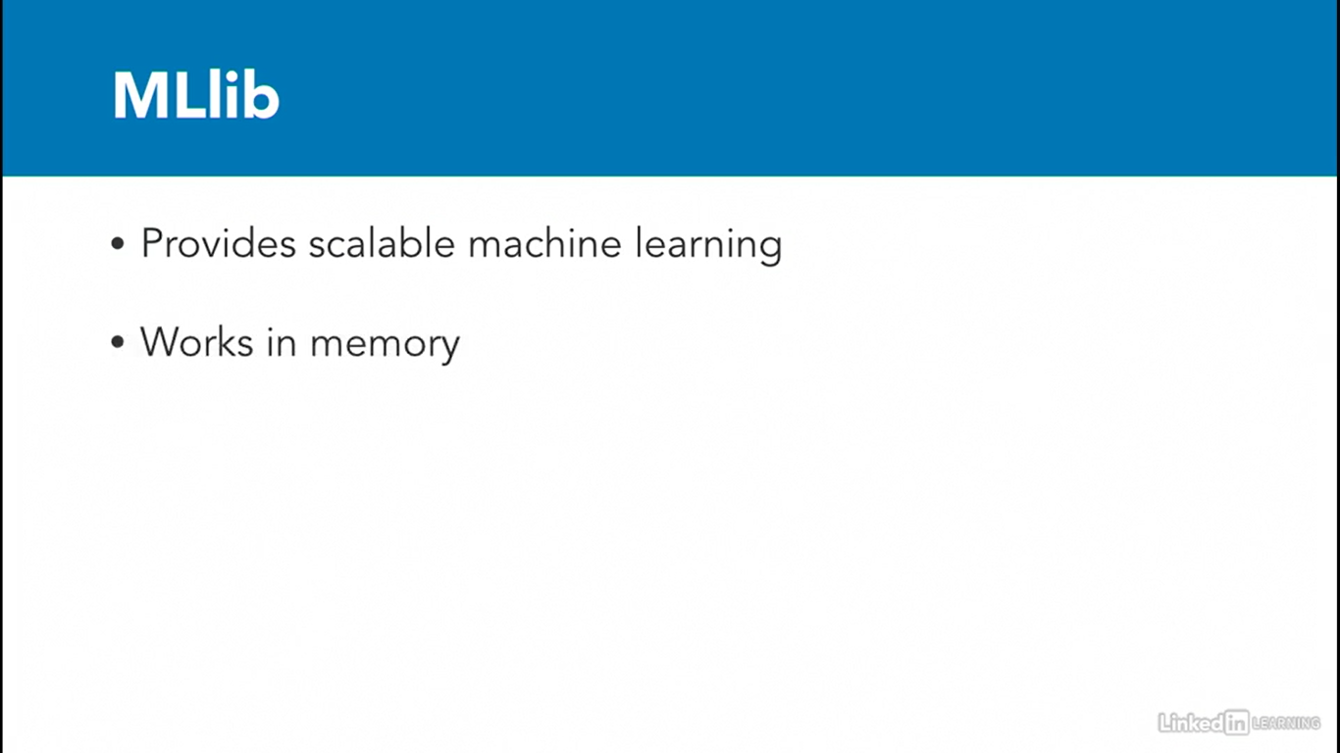

## **GraphX:**

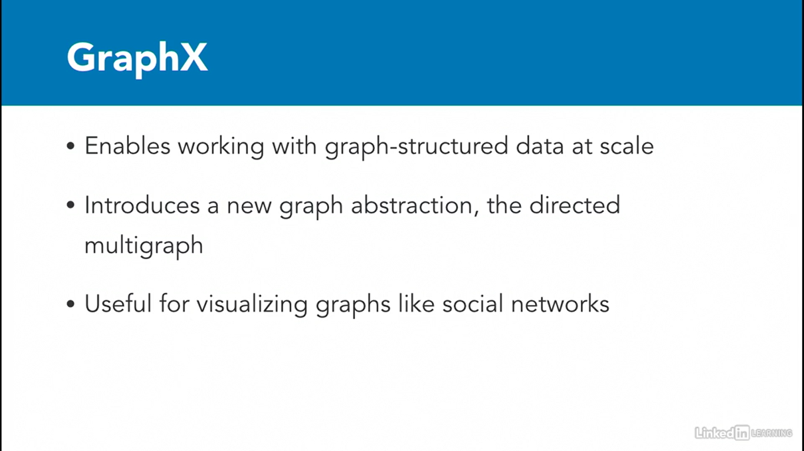

# **Pandas Vs Hadoop VS Dask VS PySpark:**

## **Pandas:**

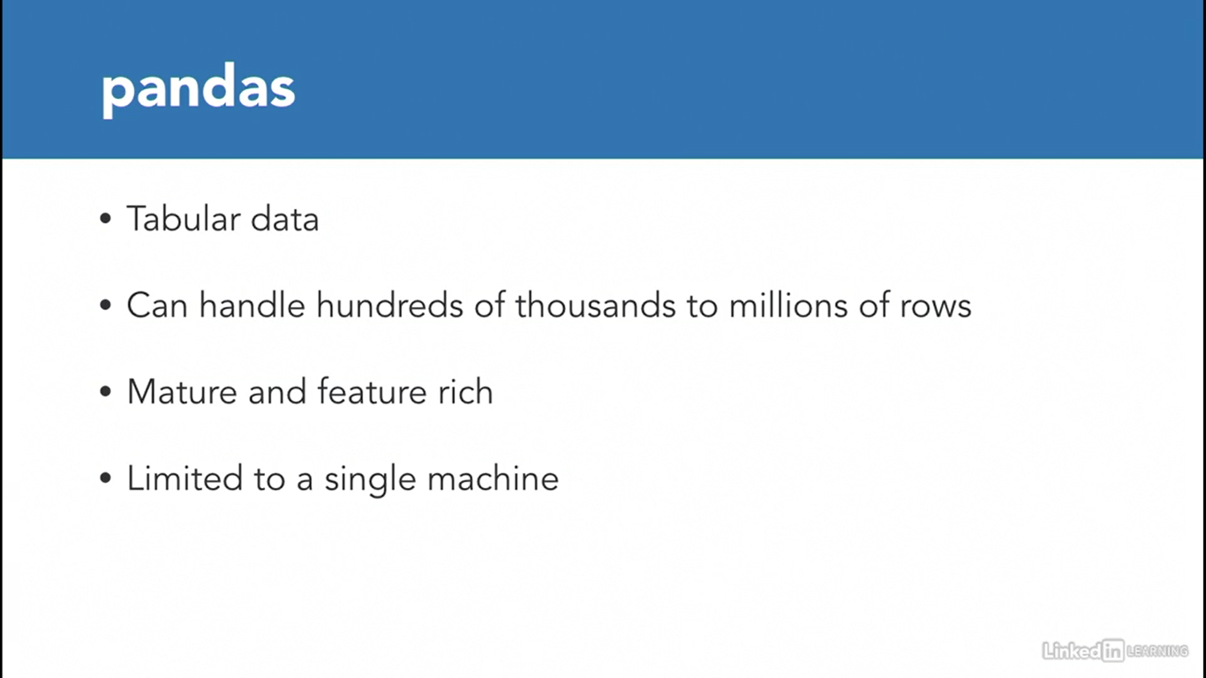

## **Hadoop:**

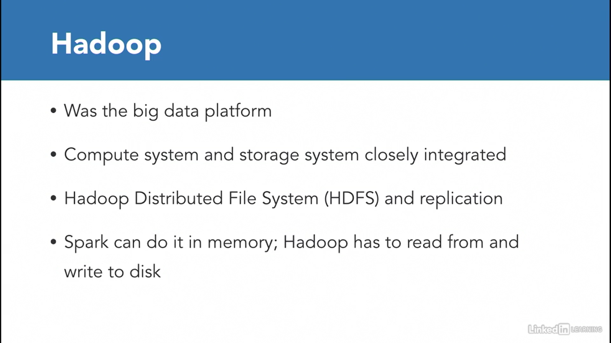

## **Dask:**

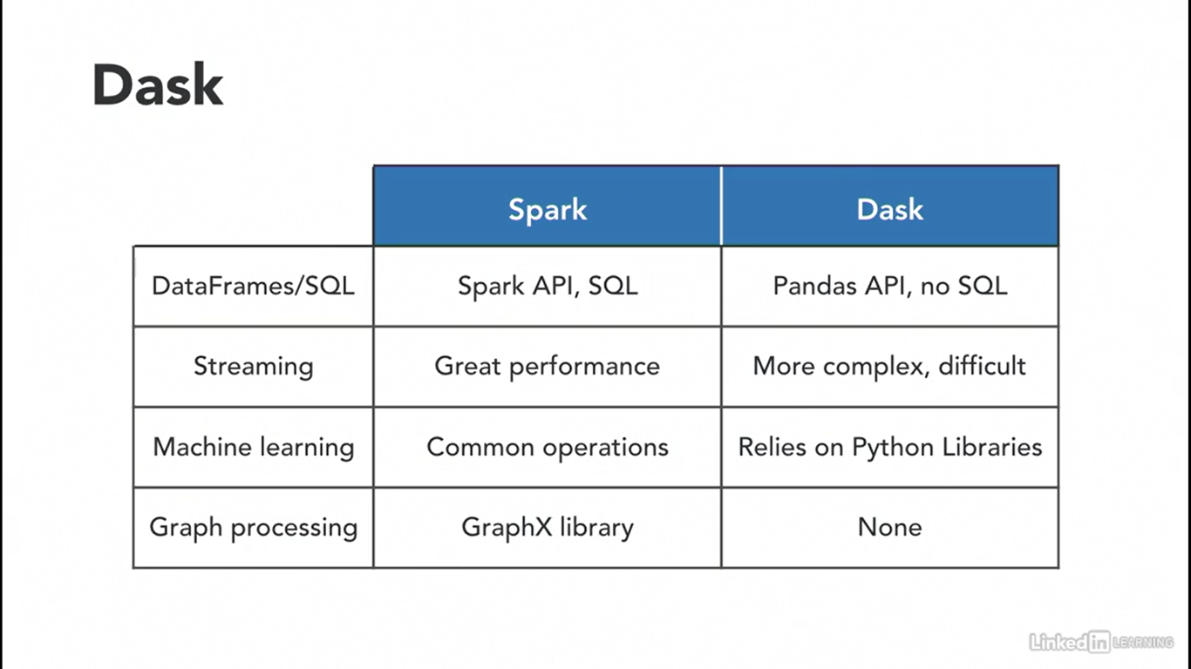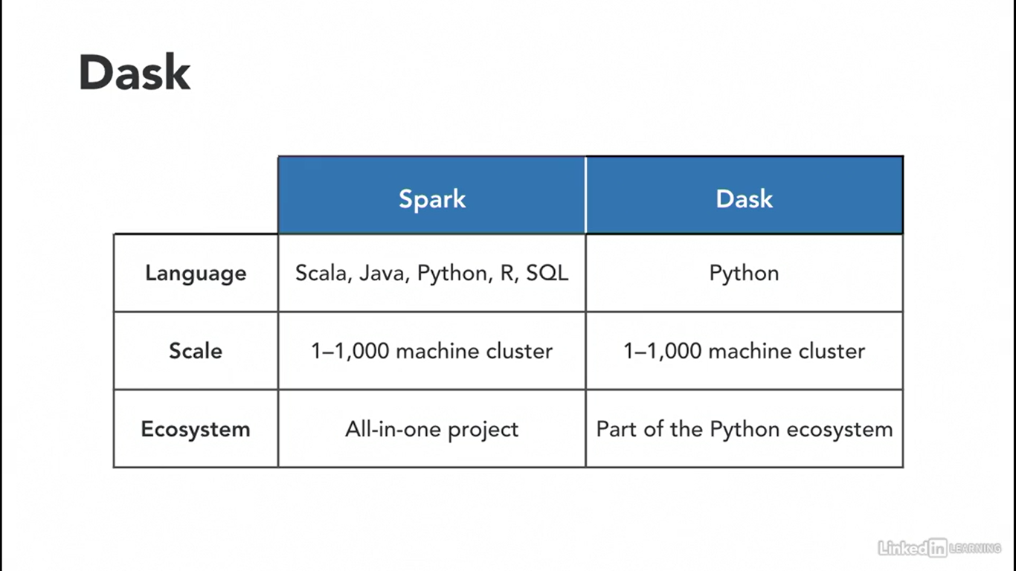

## **Spark Components:**

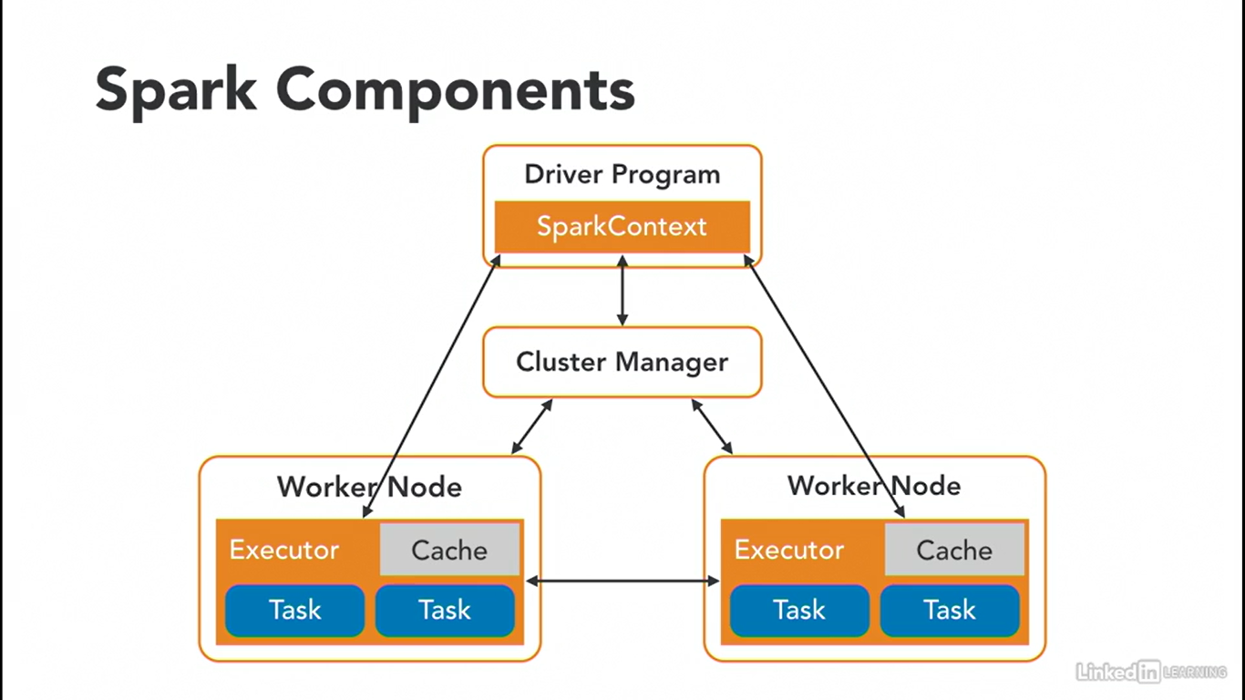

***Note: Cluster Manager is also called Task Manager***

## **Cluster Manager Types:**

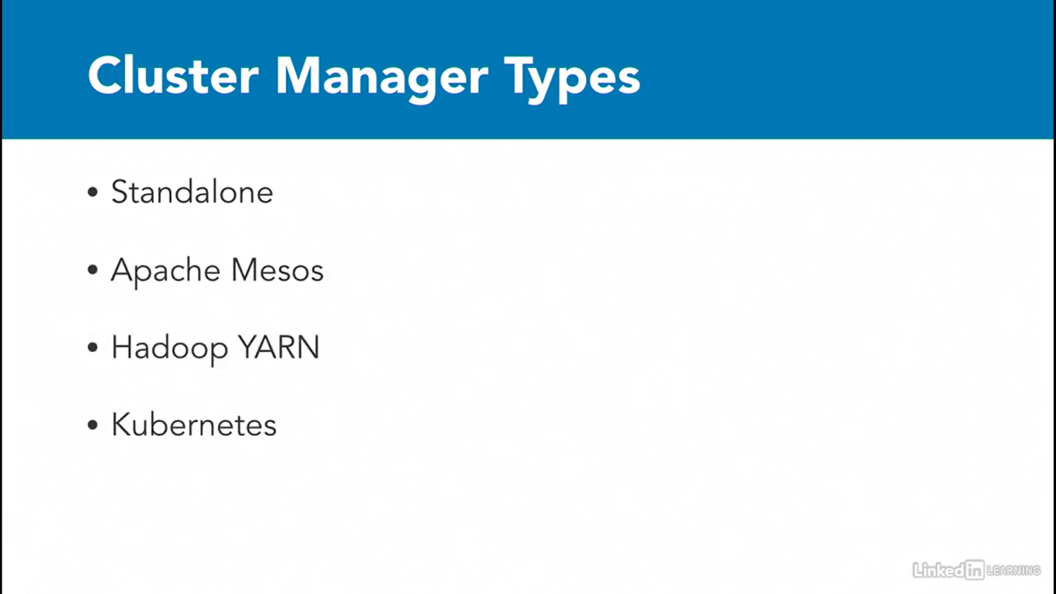

## **Creating a SparkSession:**

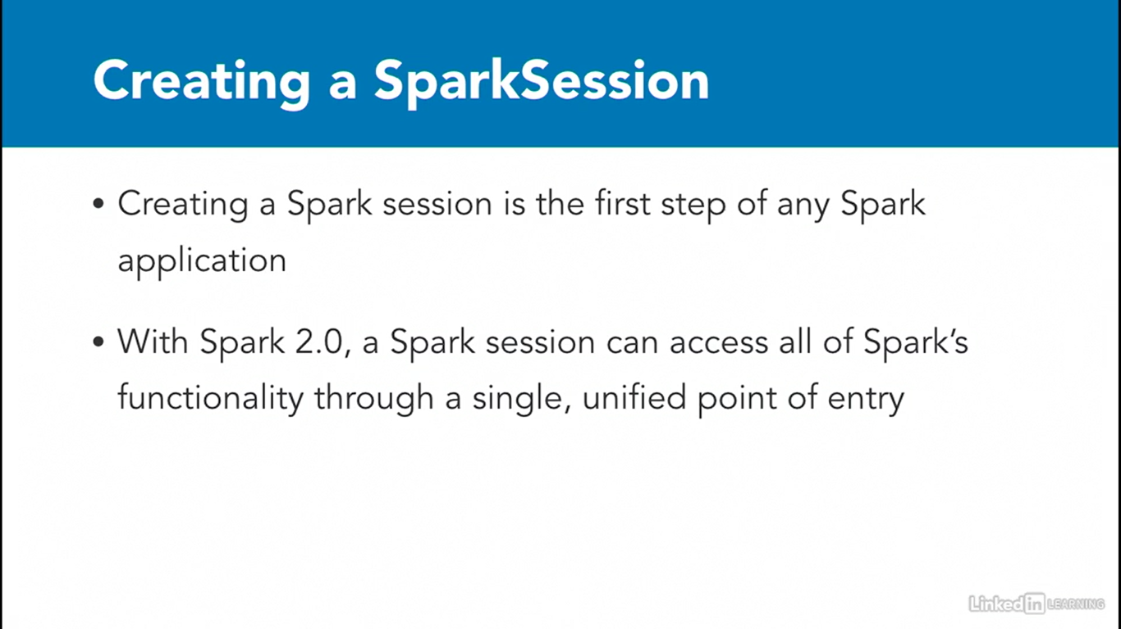

## **Partitions:**

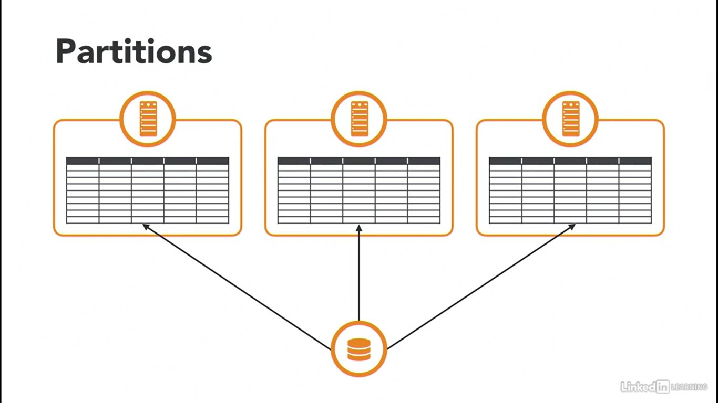

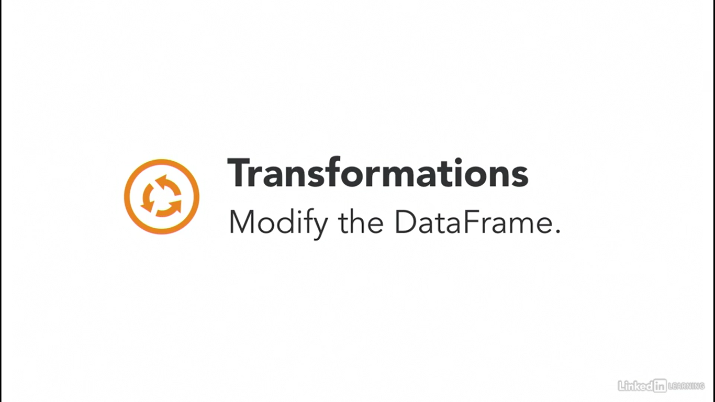

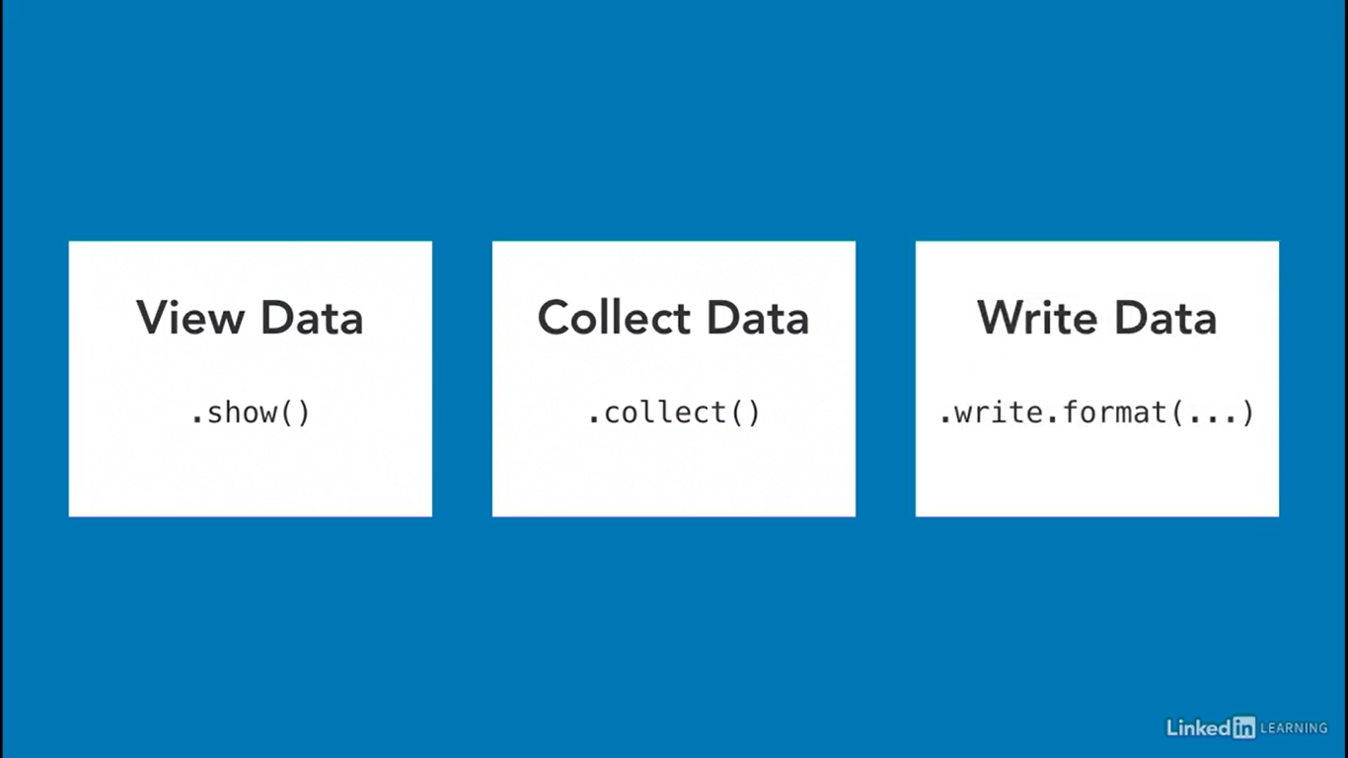

## **For Practice Dataset:**

<https://data.cityofchicago.org/Public-Safety/Crimes-2001-to-Present/ijzp-q8t2>

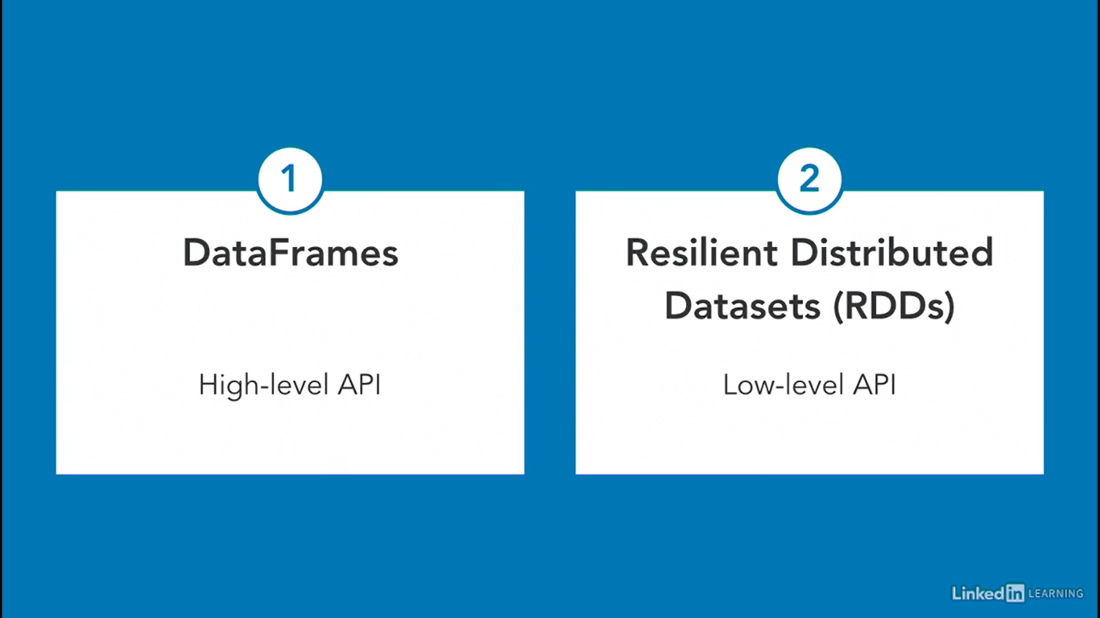

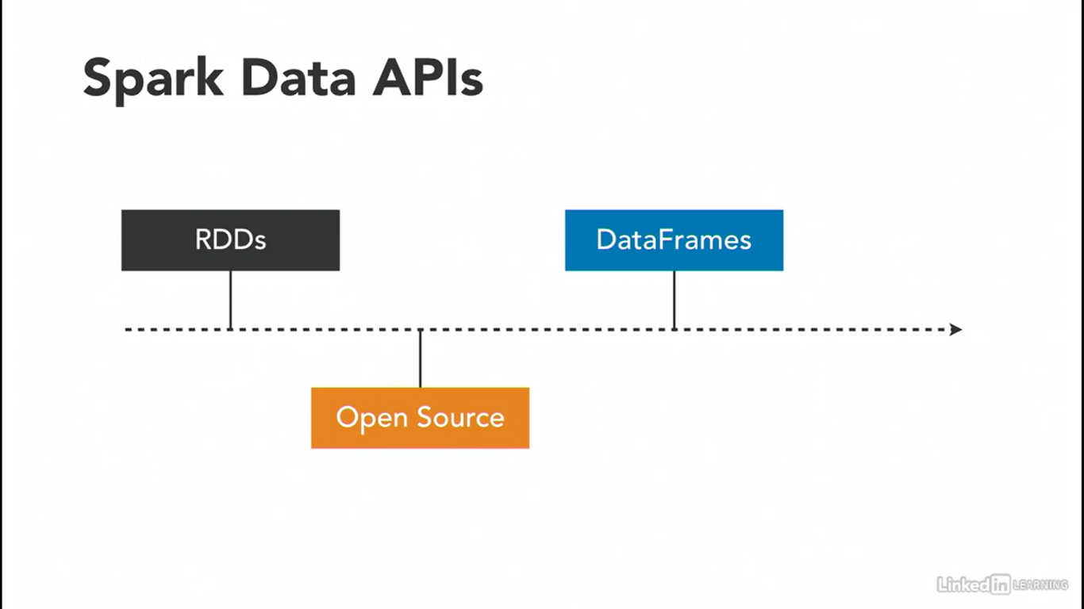

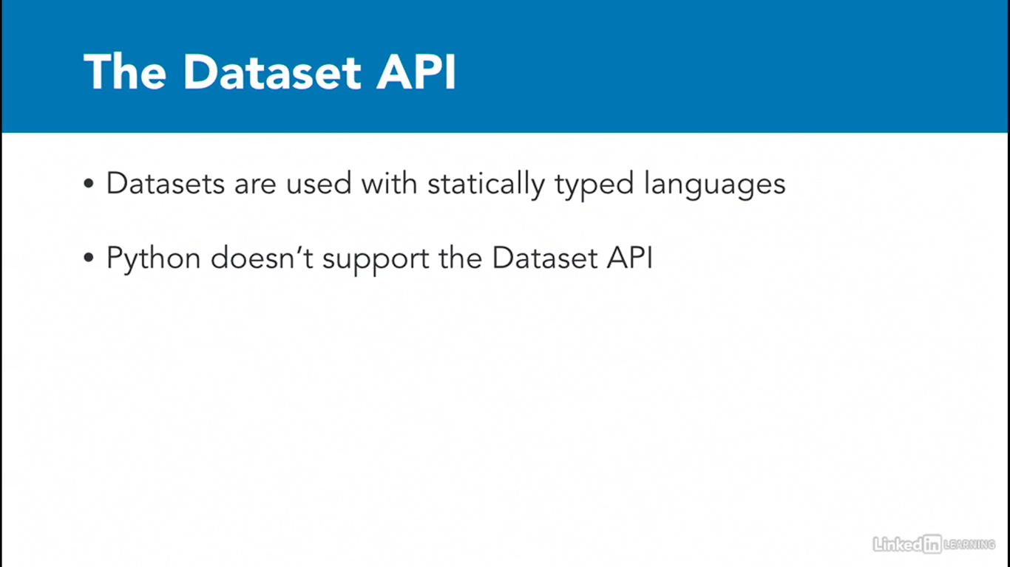

# **Working with Dataframes – Pandas VS Pyspark:**

## **Import & Initializing:**

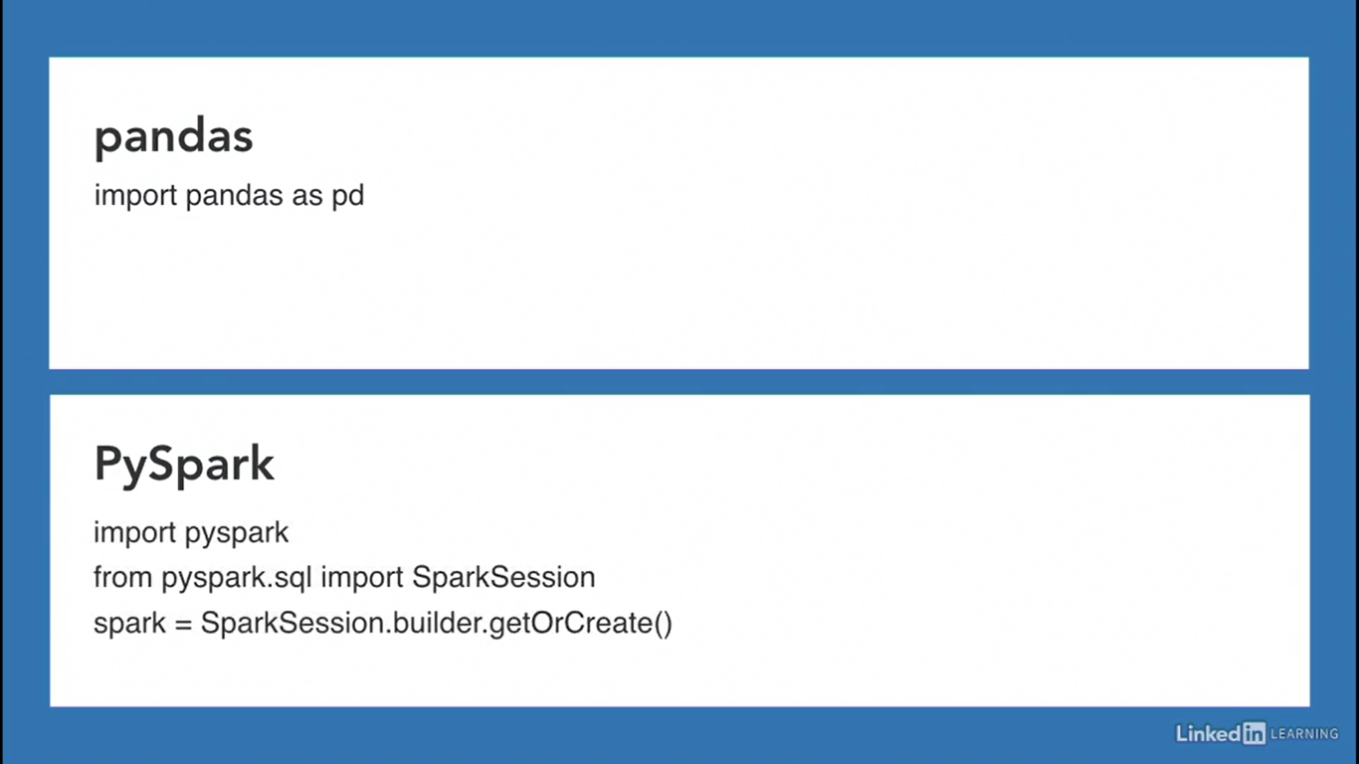

## **Reading CSV:**

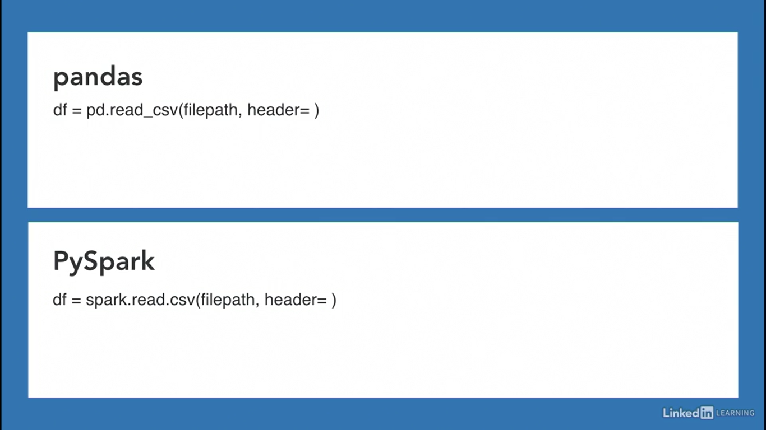

## **Show n rows:**

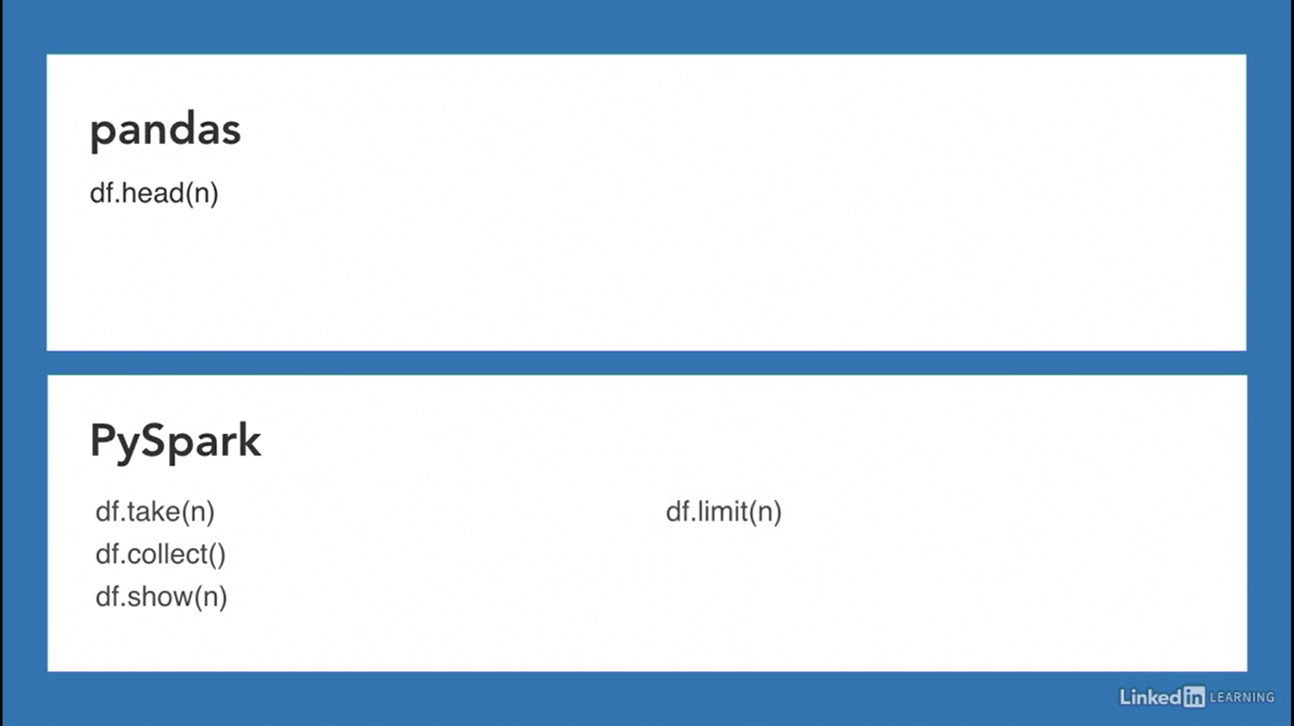

# **Work with Columns**

## **Access a Column:**

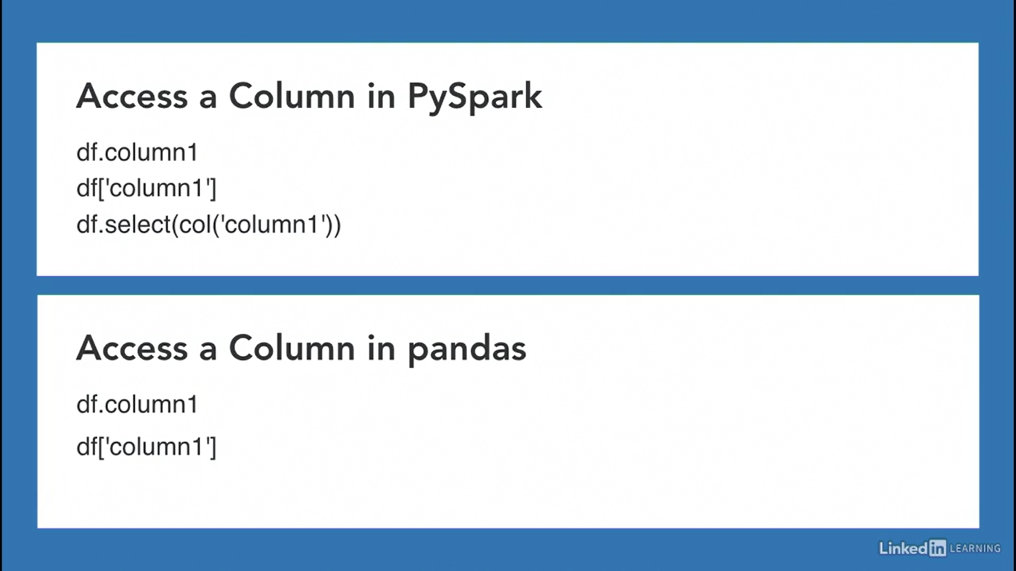

## **Work with Columns:**

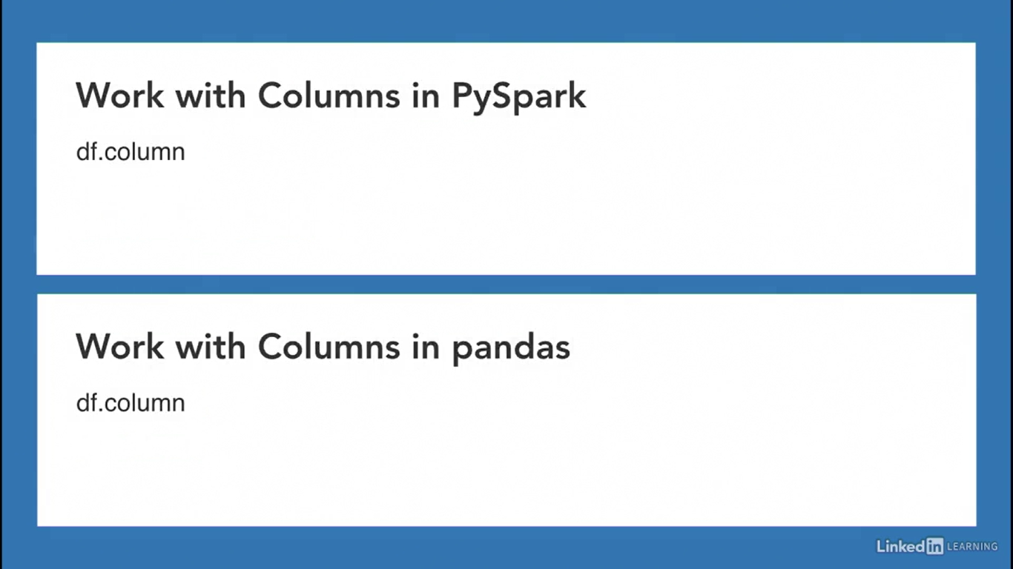

## **Select Multiple Columns:**

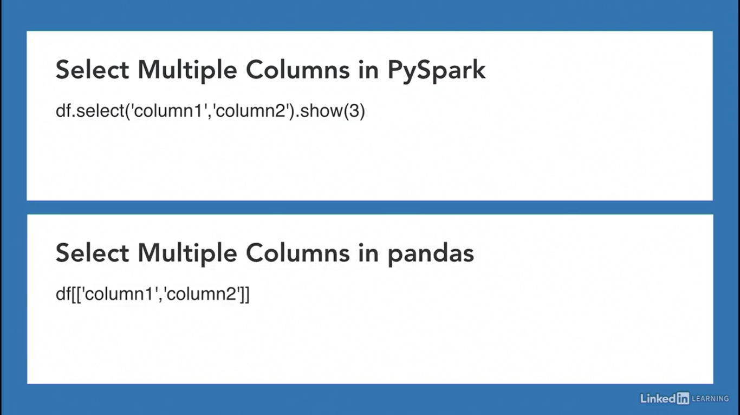

## **Add a column:**

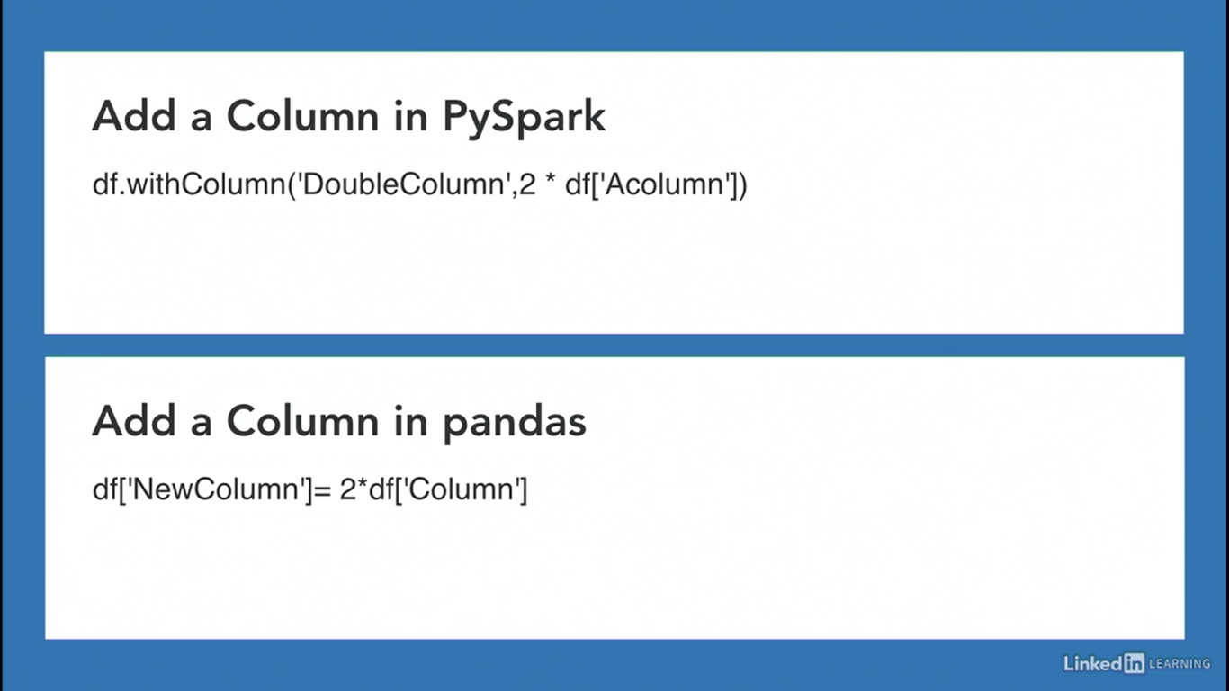

## **Rename a column:**

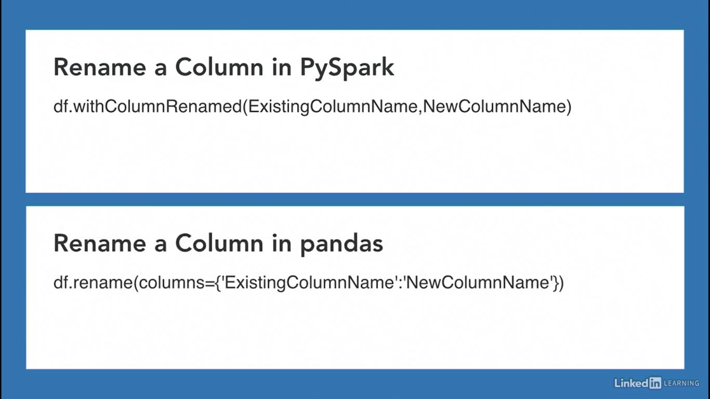

## **Remove Columns:**

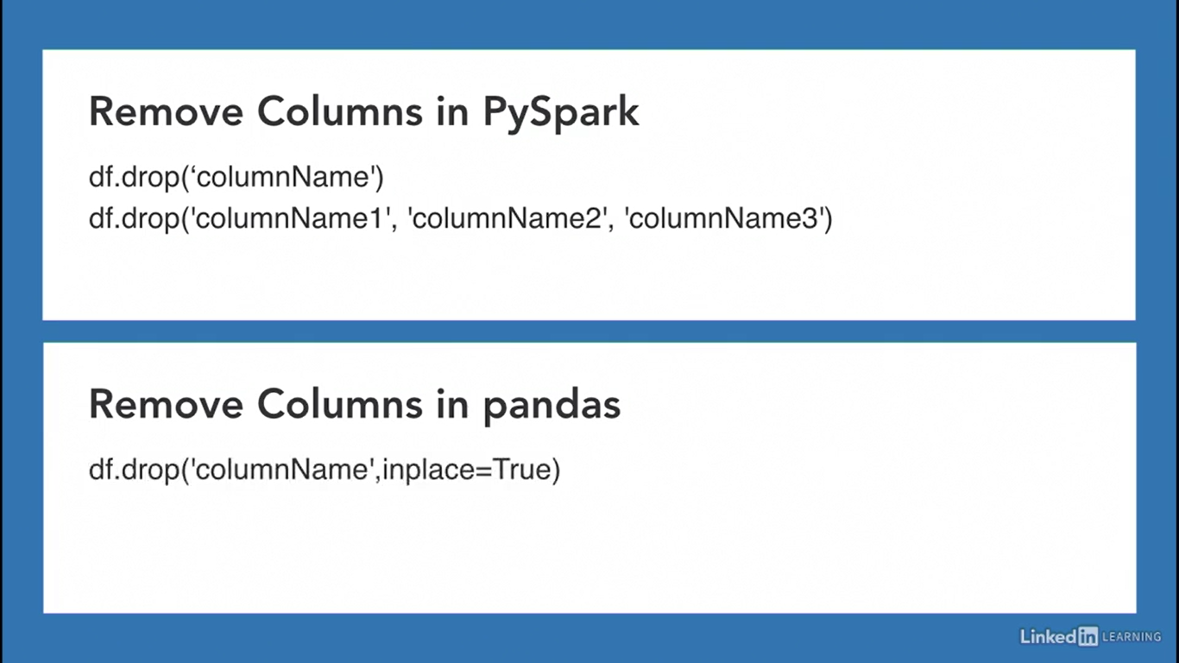

# **Work with Rows**

## **Filtering Rows:**

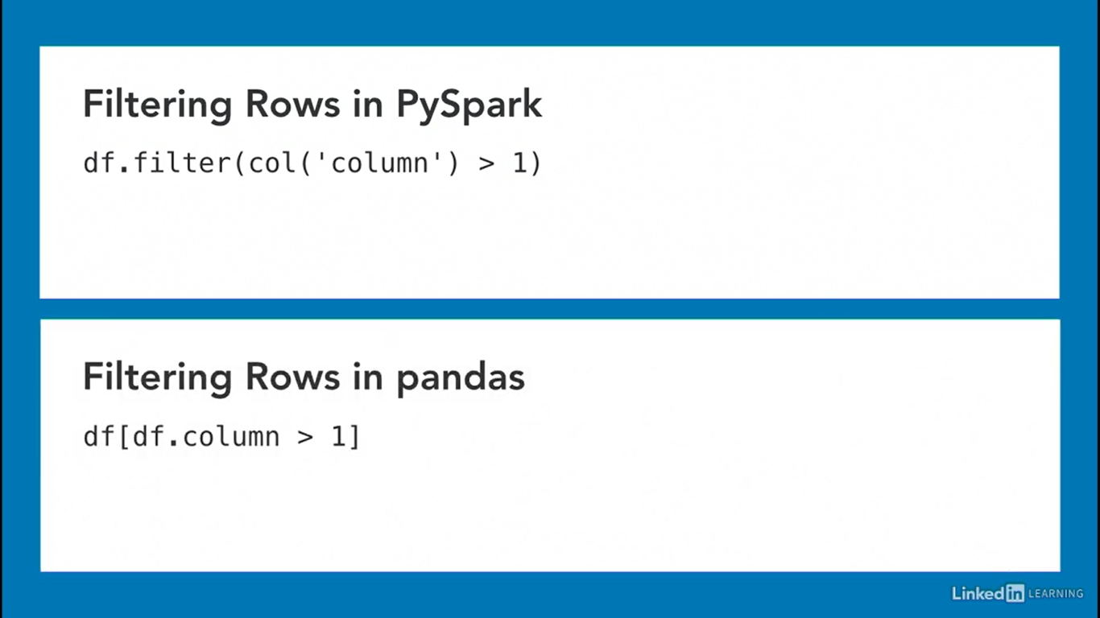

## **Get Unique Rows:**

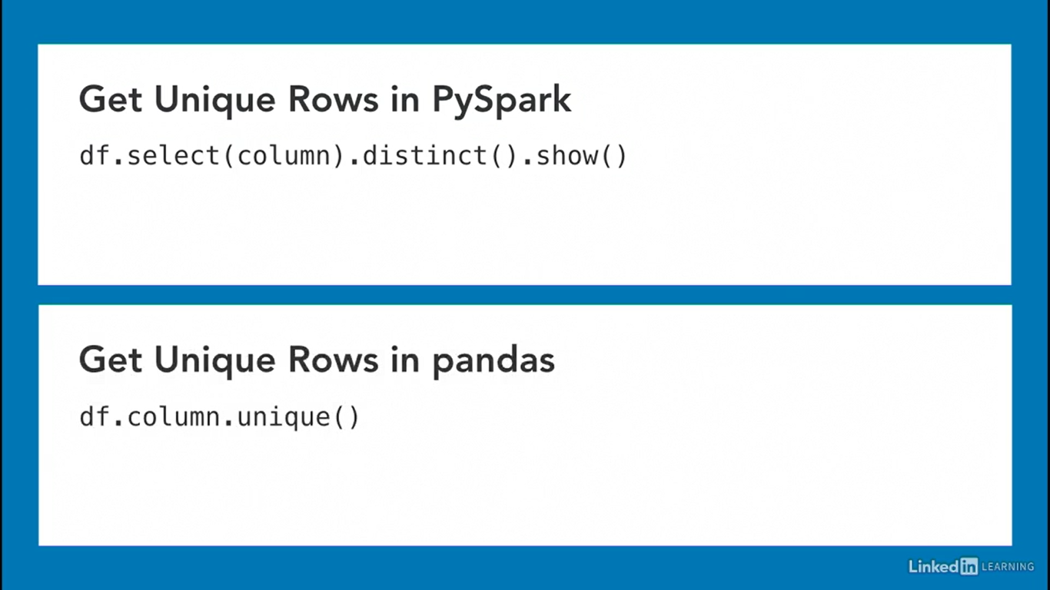

## **Sort Rows:**

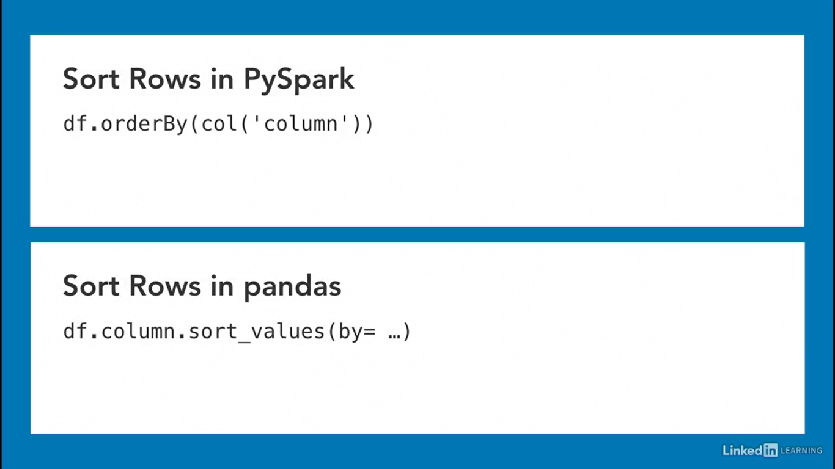

## **Append Rows:**

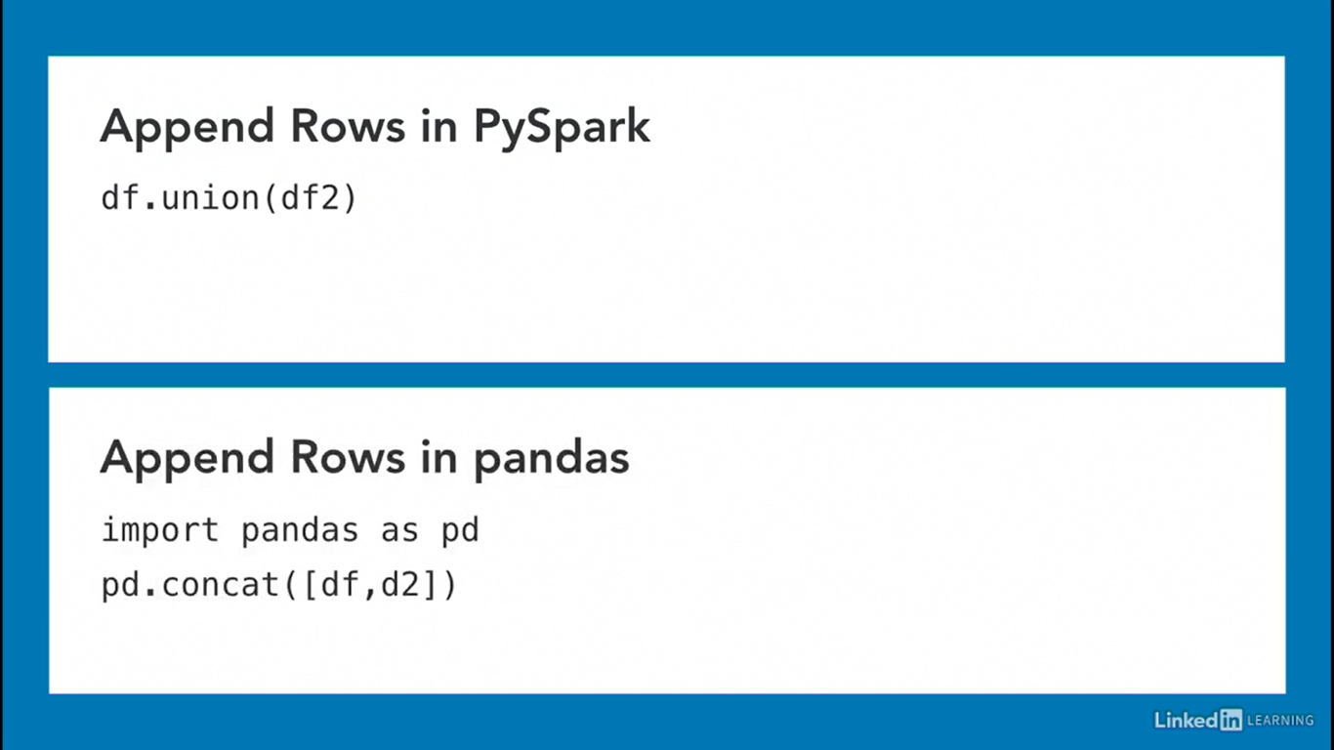

## **Schema of Pyspark:**

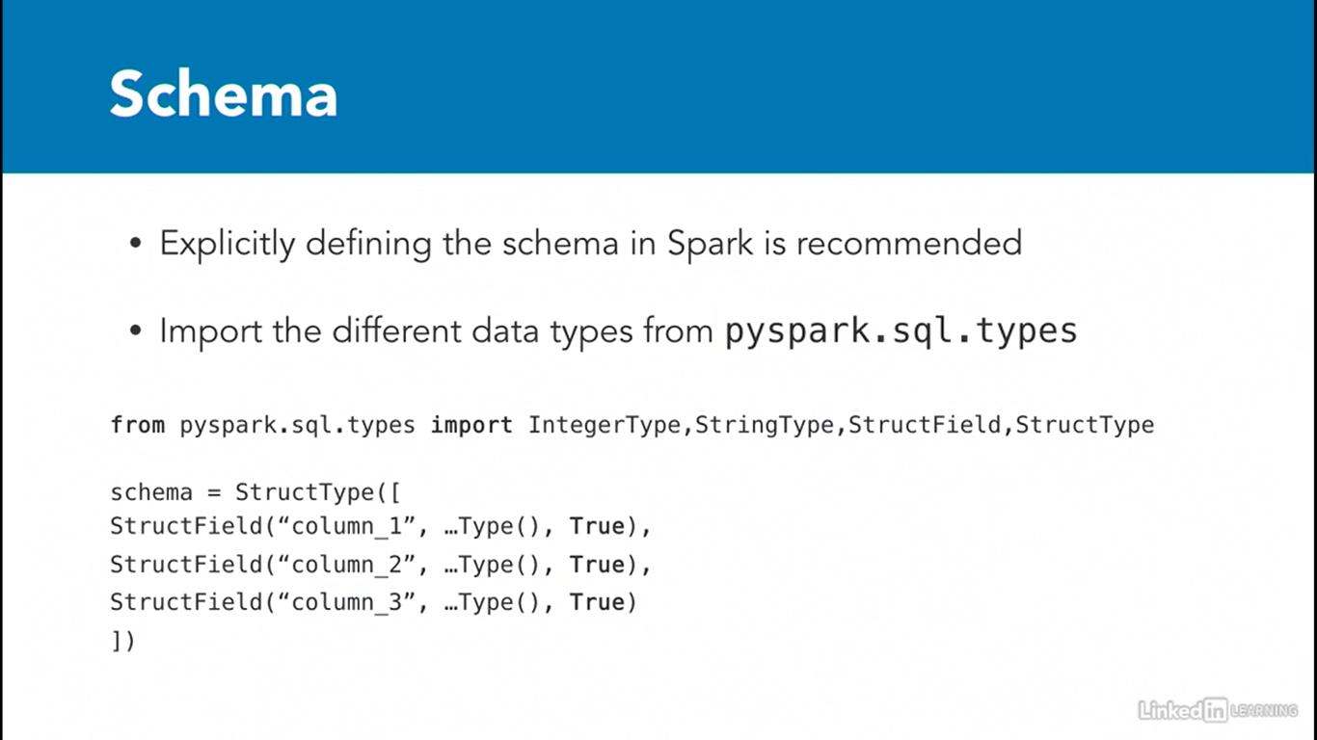

## **To print dataframe schema in Pyspark:**

rc.printSchema()

# **PySpark Built-in Functions:**

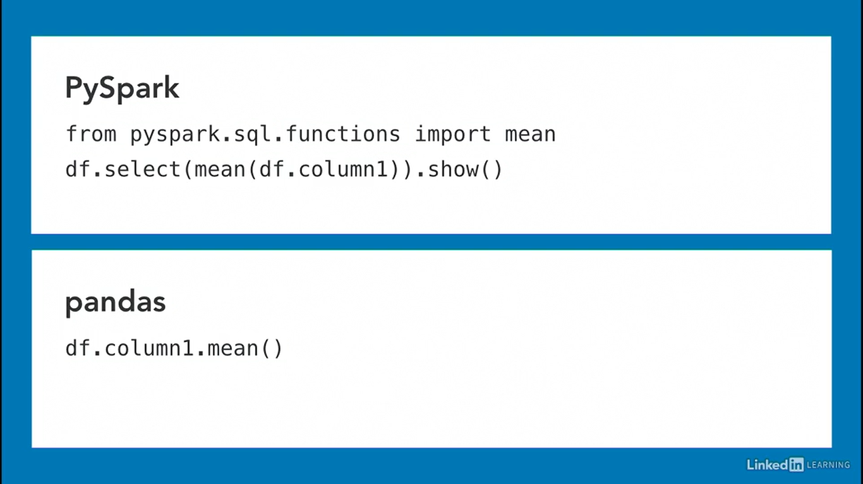

## **To Check all Built-In Functions:**

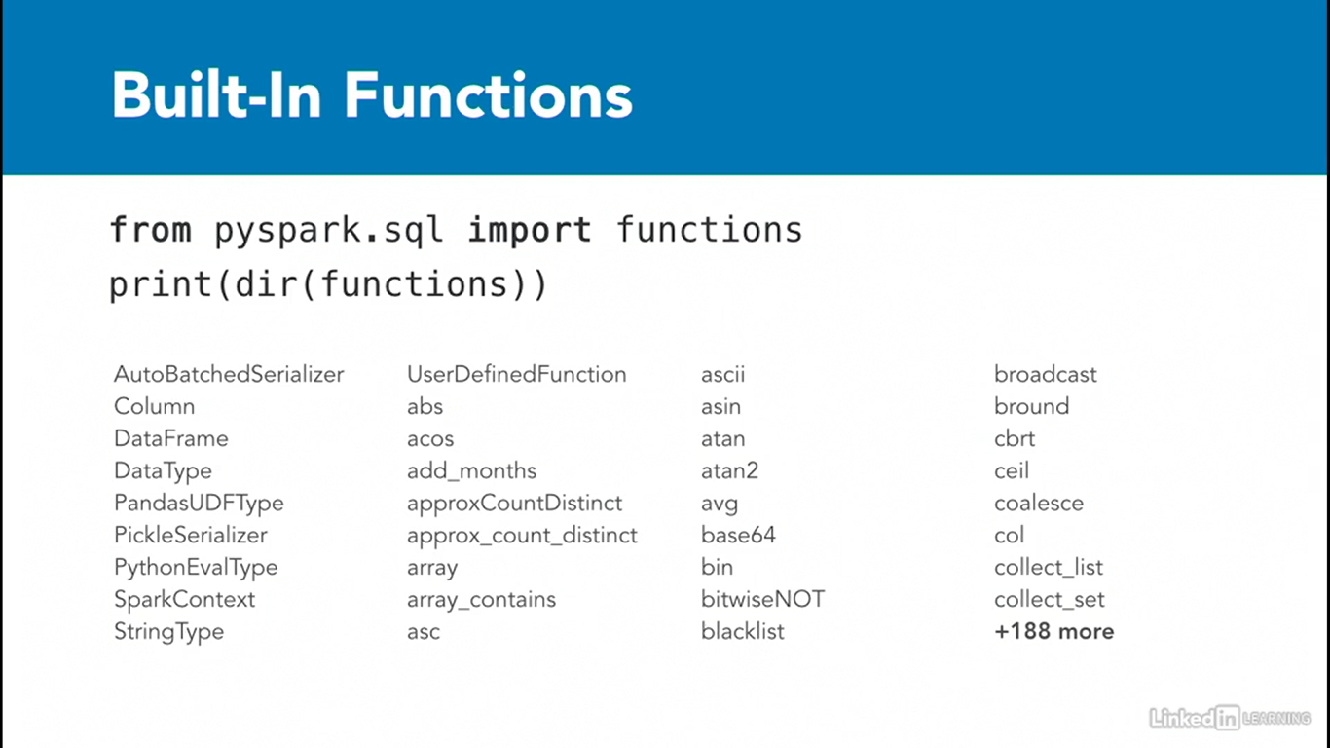

**To check Syntax of Functions:**   
  
For ex: I want to check **substring** function syntax:

help(substring)

# **User Defined Functions (UDFs) in Pyspark:**

**Language Support for UDFs:**

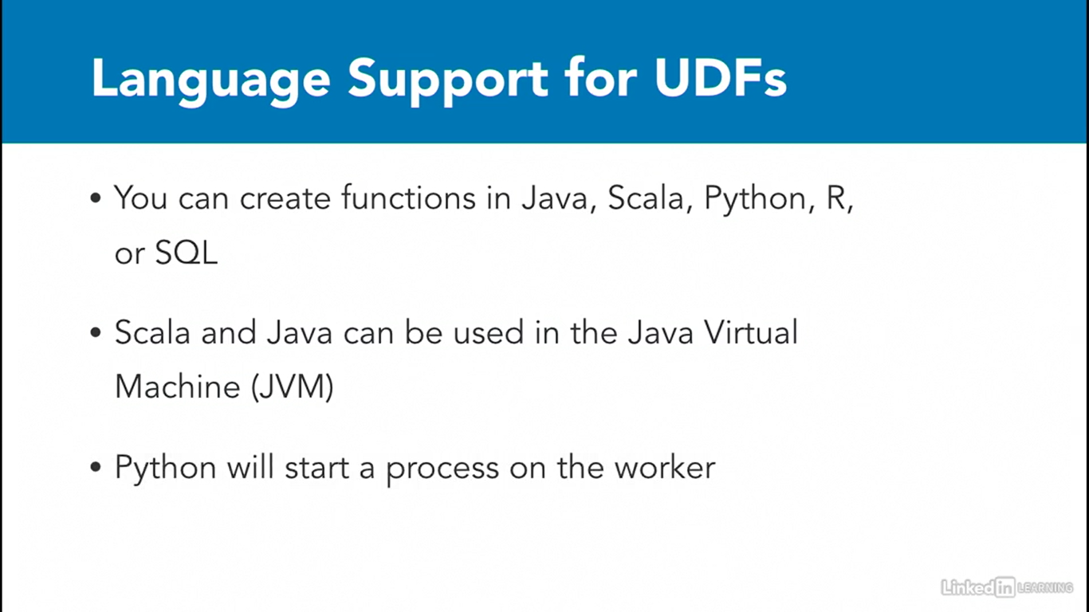

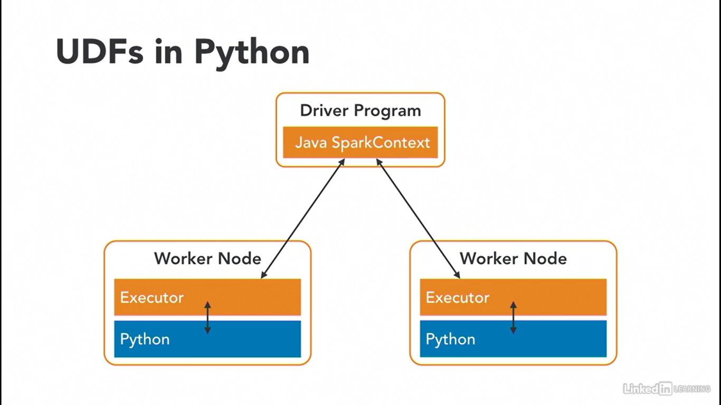

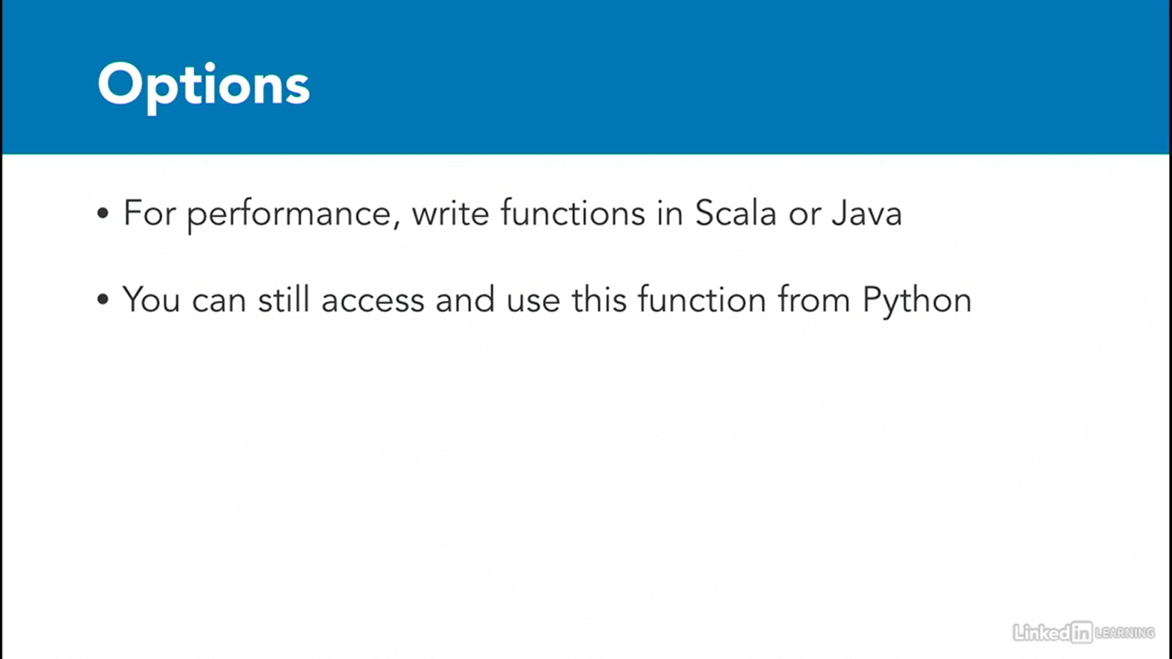

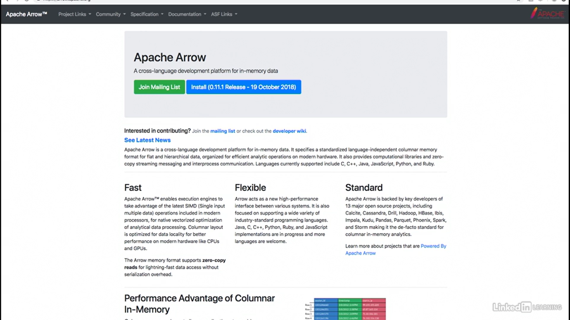

# **Joins in Pyspark:**

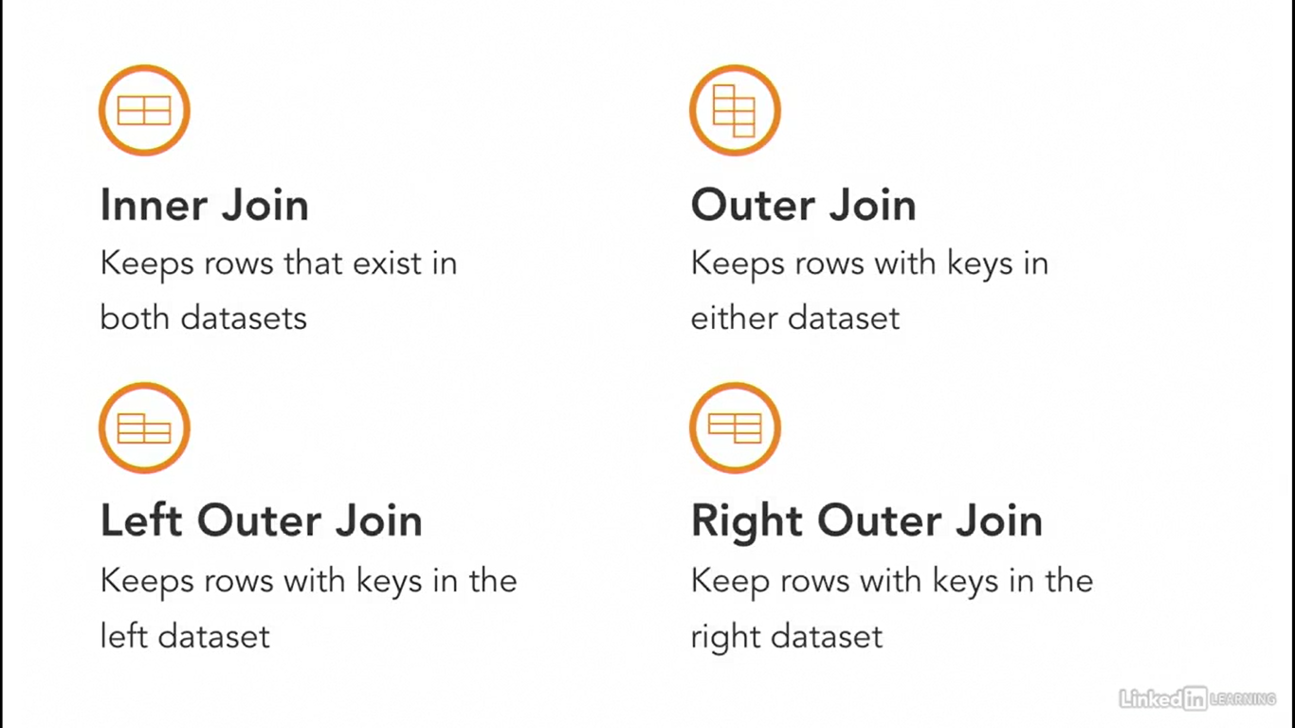

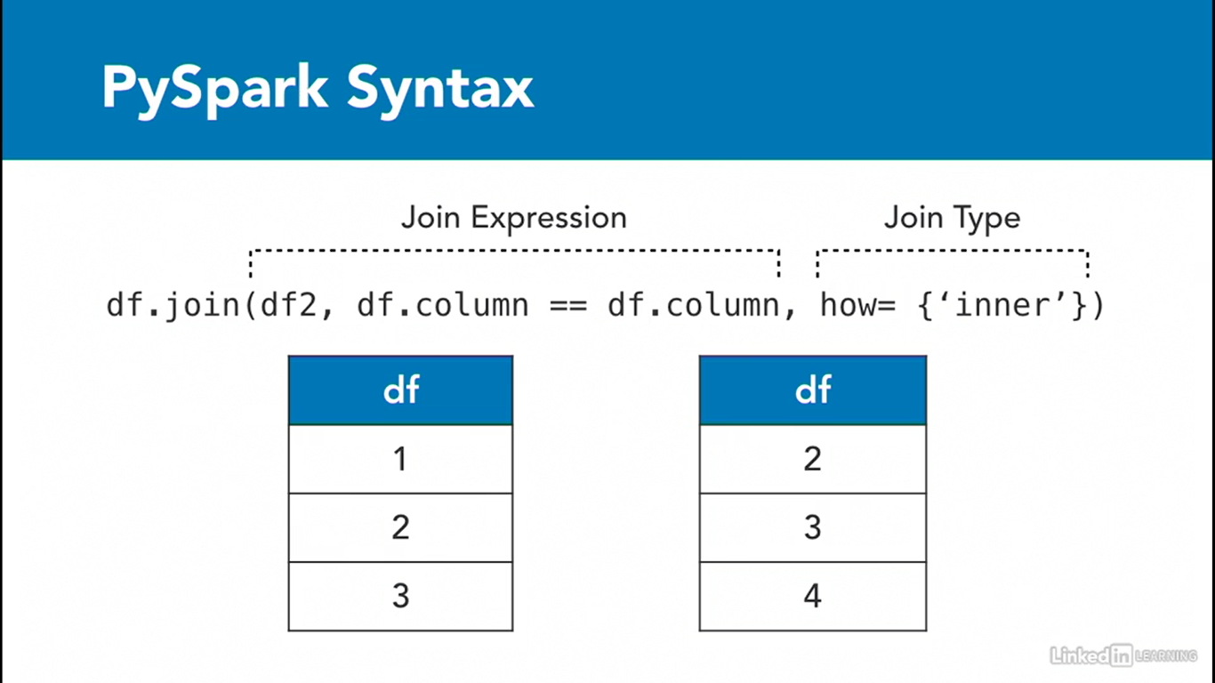

**Inner Join:**

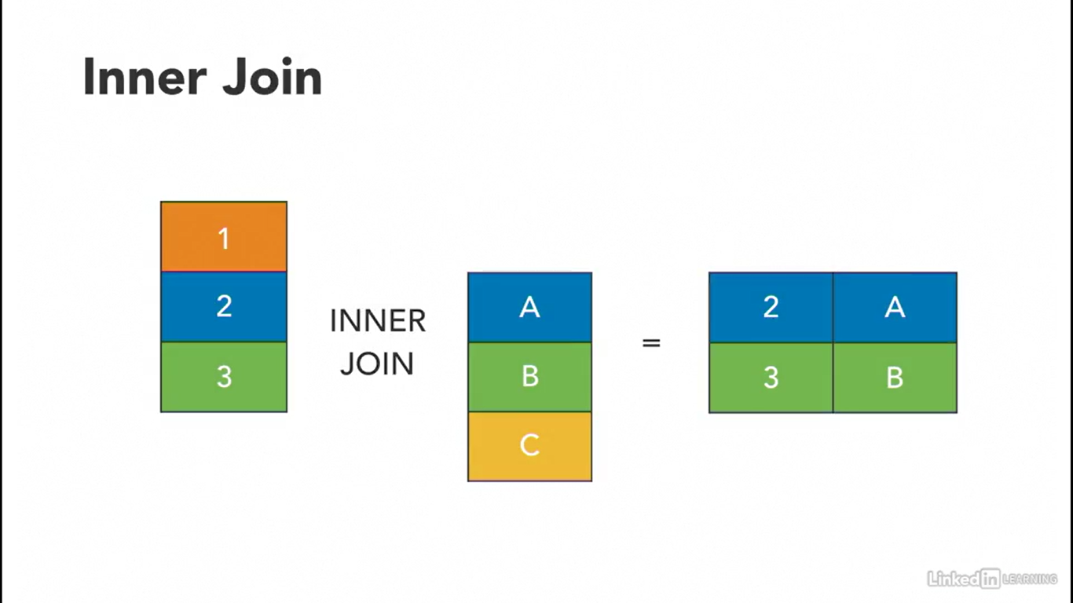

**Outer Join:**

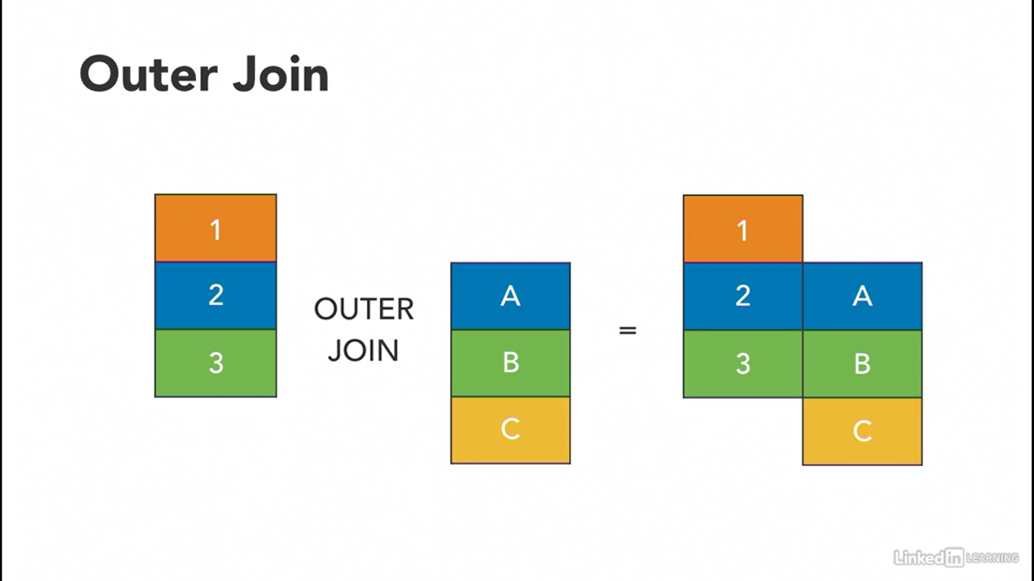

**Left Outer Join:**

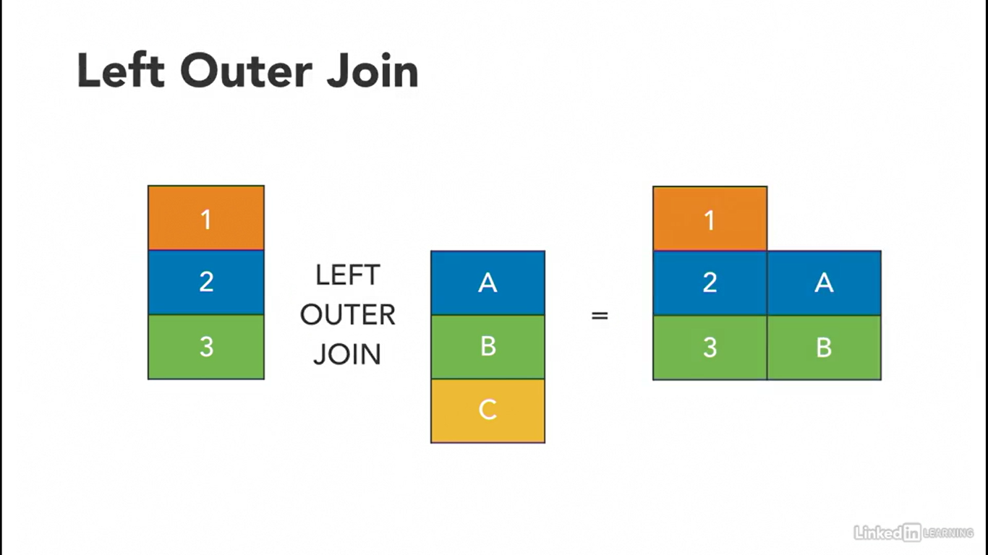

**Right Outer Join:**

